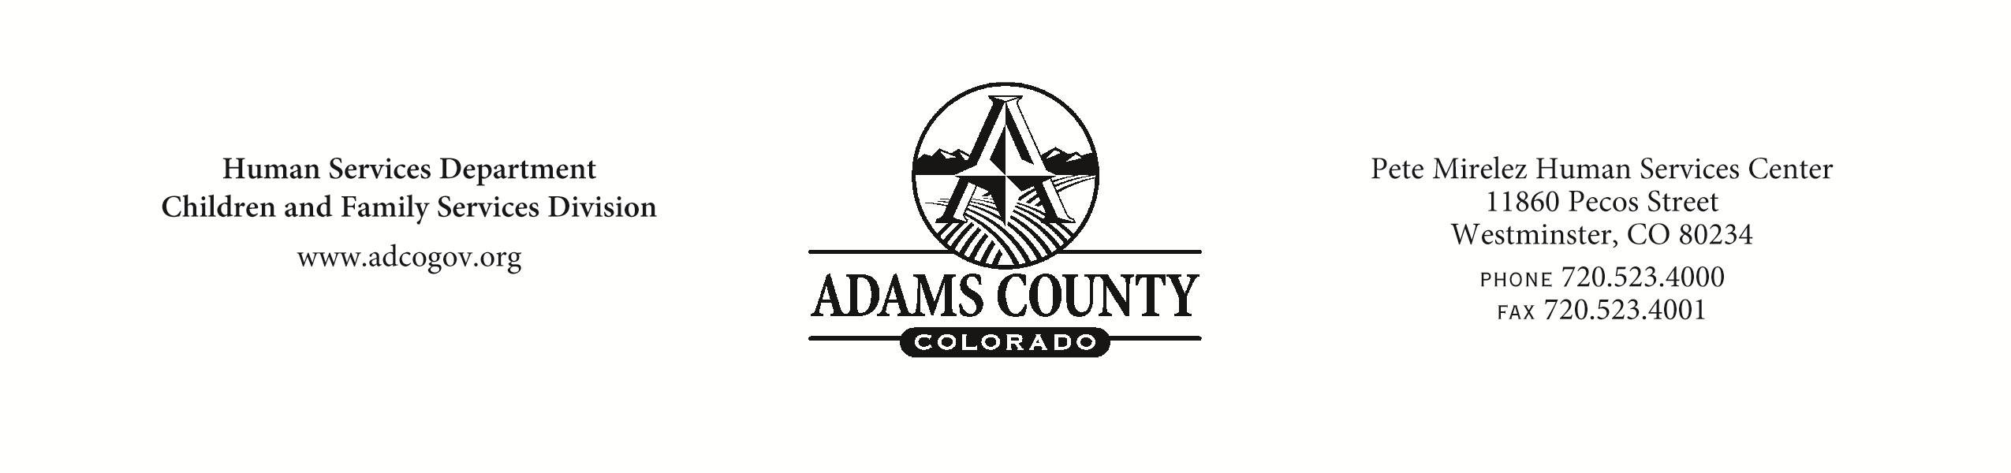
ACHSD RECORD OF ADMISSION
HH#: ___________________________

1. CHILD’S LEGAL NAME __________________________________ DOB/AGE _______________________ RACE ________GENDER _________

CHILD’S CHOSEN NAME OR NICKNAME______________________________________PRONOUNS____________________________________

SEX ASSIGNED AT BIRTH___________________ GENDER IDENTITY_________________________ SEXUAL ORIENTATION__________________

PLACE OF BIRTH ________________________________ RELIGIOUS PREFERENCE OF BIRTH PARENT/CHILD _______________________

DAT PLACED __________________________________ ADAMS COUNTY HOME CPA

CAREGIVER NAME ________________________________________________ PHONE ____________________________________________

CAREGIVER HOME ADDRESS ____________________________________________________________________________________________

PARENT’S NAME(S) ____________________________________________________ PHONE ______________________________________

PARENT’S ADDRESS ___________________________________________________________________________________________________

SIBLINGS NAMES, AGES, WHEREABOUTS __________________________________________________________________________________
____________________________________________________________________________________________________________________

2. REASON FOR PLACEMENT (be specific) ____________________________________________________________________________________
____________________________________________________________________________________________________________________

ESTIMATED LENGTH OF PLACEMENT __________________________ LEGAL STATUS COURT VOLUNTARY

GAL __________________________________________________________

3. MEDICAL CONCERNS
Injuries (describe) ____________________________________________________________________________________________________
____________________________________________________________________________________________________________________
Medical Problems ____________________________________ Allergies _____________________________________________________
Seizures ____________________________________________ Mental Retardation ___________________________________________
Physical ____________________________________________ Handicaps ___________________________________________________
List of all Medications _________________________________________________________________________________________________
Illnesses Over Past 6 Months ____________________________________________________________________________________________
Other ______________________________________________________________________________________________________________

4. KNOWN BEHAVIORS WHICH COULD ENDANGER CHILD OR OTHERS
Assaultive Property Destruction Running Away Self Destructive Substance Abuse Suicidal Severe Eating Disorder Tantrums Other (describe) _____________________________________________________________

5. EDUCATION
Grade ________________________ Former School ________________________________________________________________________

Special Education______________________________________________________________________________________________________

6. VISITS
Who can call or visit children immediately? ________________________________________________________________________________
____________________________________________________________________________________________________________________
DO NOT give Bio-Parents address and phone number of Foster Family Child Abuse/Neglect Hotline # 303-412-5212

_________________________________________________________ ___________________________________________________________
Print Worker’s Name , Date, Phone # Print Supervisor’s Name, Date, Phone #

White-Case File Yellow-Caregiver Pink-Foster Care Certification Supervisor (if Adams County Foster Home) ACHSD-169A (Rev.7/21)

