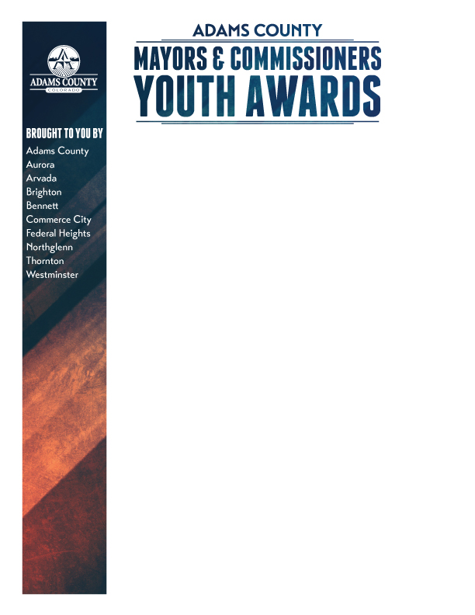

2016 - 2017 Nomination Form
Mayors and Commissioners Youth Award

The Adams County Mayors and Commissioners Youth Award (ACMCYA) program recognizes teenagers in grades 6th through 12th, or those young people who may not currently be in a school setting but are 20 years of age or less. We encourage you to nominate those who may have overcome personal adversity to create positive change in their lives and with those around them. This program provides businesses, the community and civic leaders an opportunity to actively demonstrate their support for the young people in all of our communities and recognize them for their accomplishments..
The Adams County Mayors and Commissioners Youth Award focuses on teenagers who have triumphed over great odds and serve as inspirations and role models for their peers. If you know of a student who would be good candidate to be recognized by the community, please help us identify them by completing the attached nomination form.

Mission of the ACMCYA
To identify and recognize teenagers who have overcome personal or physical obstacles and risen to challenges life has presented to make a positive difference in them and those around them.

Recognition Structure

The ACMCYA is a 2-tiered recognition program that honors nominees at both the local level and countywide. Typically, all nominees are recognized by their local governmental entity. Following that recognition, then an additional screening process will determine the top 20 nominees amongst all of the submissions to be honored at the countywide recognition and awards event.
When completing the nomination form please be specific as to why you think your nominee should receive this award. As you fill out these forms, keep in mind that the more information you include, the easier it will be for the screening committees to recognize what makes these young people so special. We realize that some of the information may be sensitive. Please indicate if any of the information needs to be kept confidential.
2016-2017 Nomination Form
Adams County Mayors and Commissioners
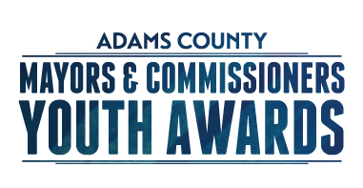
Youth Award

Details
1. Nomination forms must be received no later than January 27, 2017.
2. Please indicate if any part of this information should be kept confidential, only to be used in the selection process.
3. Nominee’s age as of December 31, 2016 must be in grades 6th through 12th and 20 years of age or less.

4. All nomination forms must be signed and mailed to the individual City/County Coordinator. No forms will
be accepted without the nominee’s signatures. (Electronic Copies are acceptable)

5. The Adams County Education Consortium (ACEC) is coordinating the program. Chuck Gross, Executive Director,
is able to provide guidance, along with the individual city and county coordinators.

Step 1 - Tell us about your nominee. (Please enter information in the fields below and fill the form out completely.) PLEASE TYPE OR PRINT LEGIBLY.
Date: Gender: Male Female
Name of Nominee: Nominee’s Phone:
Address: City: County: Zip Code:

If student, school attending: Grade Level (if applicable):

Email:
Nominee’s age as of 12/31/16: Date of Birth:
Nominator’s Name: Nominator’s Phone:
Address: City: Zip Code:

Nominator’s Relationship to Nominee: Email:

Additional Contact Person: Phone:

Address: City: Zip Code:

Relationship to Nominee: Email:
To the best of my knowledge, all the information provided in this application is true and reflects the nominee accurately.
I have made note of specific information about the nominee that needs to be kept confidential.
_______________________________________________
Signature of Nominator Date
To be filled out by the City/County Coordinator
Nominee__________________________________ City_____________________________
Step 2 - Tell us why your nominee deserves this award.
Please be as specific as you can and use additional sheets if necessary. Pertinent supplementary material may be included. (Please fill this form out completely by typing or printing legibly in the form fields below.) Nominations with very brief, illegible or incomplete information may not be given as much consideration.
Provide as much information and as many specific examples as possible. (Examples might include: overcoming physical, emotional, or other challenges; providing financial or emotional support to family and friends; care of sick or elderly sibling, parent, or friend; providing positive leadership and role modeling for other youth; positive behavioral changes; and/or community involvement.)

YOU MAY USE ANOTHER SHEET IF THERE ISN’T ADEQUATE WRITING SPACE:
1. Describe the personal adversity, difficult environment, or limitations your nominee has overcome.

2. What were the key factors that helped your nominee turn his/her adversity to advantage?

3. In what ways has your nominee benefited himself/herself, other youth, their family, or their community?

4. Why do you feel your nominee should receive this award?

Completed Nomination Forms are to be submitted electronically to the address below.

Aurora – Chanell Reed creed@auroragov.org
Arvada - Maria Vanderkolk mvanderkolk@arvada.org
Bennett – Jose Rocha jrocha@bennett.co.us
Brighton - Tawyna Russell trussell@brightonco.gov
Commerce City – Shannon Whitmer swhitmer@c3gov.com
Federal Heights - Clelia McVay cmcvay@fedheights.org
Northglenn - Jenni Murphy jmurphy@northglenn.org
Thornton – Jennie Christoffel Jennie.Christoffel@cityofthornton.net
Westminster - Joe LeDuc jleduc@cityofwestminster.us
Unincorporated Adams County - Katie Burczek kburczek@adcogov.org

To be filled out by the City/County Coordinator
Nominee__________________________________ City_____________________________

